# Development of Pig Clinical Decision Support System

A Thesis

Presented to

The Faculty of the College of Computer Studies

Rizal College of Taal

In Partial Fulfillment

Of the Requirements for the Degree

Bachelor of Science in Computer Science

Group 7

De Roxas, Irish John S.

Sacdalan, Ruben

Piñon, Jorgel

**2023**

## **APPROVAL SHEET**

In partial fulfilment of the requirements for the degree of Bachelor of Science in Computer Science, this project feasibility study entitled “Spelling Checker through Image Processing Technique”,prepared and submitted by **DEROXAS, IRISH JOHN S., SACDALAN, RUBEN, PIÑON, JORGEL** has been examined and recommended for acceptance and approval for Oral Examination.

**MR. CHRISTIAN AGUSTIN**

Adviser

Approved by the Committee on Oral Examination with a grade of _________.

**PANEL OF EXAMINERS**

**Panel 1 Panel 2**

**Chairman**

## Copyright 2023

All rights reserved. No part of this publication may be reproduced, distributed, or transmitted in any form or by any means, including photocopying, recording, or other electronic or mechanical methods, without the prior written permission of the publisher, except in the case of brief quotations embodied in critical reviews and certain other noncommercial uses permitted by copyright law.

Any references to historical events, real people, or real places are used fictitiously. Names, characters, and places are products of the author’s imagination.

Front cover image by Researcher.

Book design by Researcher.

First printing edition 2022.

## DEDICATION

To our Almighty God, supportive adviser, research adviser, subject teachers, for the future researchers, our dedicated parents for their reassuring, inspirational and unfailing cooperation in the completion of this study. This study is lovingly dedicated.

## ACKNOWLEDGEMENT

This work is the result of a lot of effort, encouragement, and inspiration from the following persons who contributed to the study's success and made suggestions for the conception of this research.

This research study has been made possible by the guidance of the following:

The researchers owe it to our **Almighty God** who always been there for us and ensures the researchers' safety.

Their deepest gratitude is extended to their **parents** who had given them all their support and love that kept them to do this research well-done.

To our thesis adviser**, Mr. Christian Agustin** and also to **Mrs. Lucena G. Piol**, who assisted the researchers in writing this study independently and showed tolerance and faith in them by making accommodations so that they could produce the best research project.

And lastly, to those persons who not being mentioned directly and indirectly helped the researchers while working and accomplishing on this research project

**RESEARCHERS:**

**DEROXAS, IRISH JOHN S.**

**SACDALAN, RUBEN**

**PIÑON, JORGEL**

## Abstract

**Table of Contents**

Title Page I

APPROVAL SHEET II

Copyright 2023 III

DEDICATION IV

ACKNOWLEDGEMENT V

Abstract VI

**Chapter I - Introduction**

Project Context 1

Purpose and Description 1

Objective of the Study 2

Scope and Limitations 2

**Chapter II - Review of Related Literature**

Technical Background 4

Local Studies 8

Foreign Studies 10

Synthesis 13

**Chapter III Design and Methodologies**

Design and Methodologies 15

Fig. 3.1 IPO Diagram 15

Knowledge Requirement 16

Software Development Method 16

Fig. 3.2 Agile Development Methodology 17

Fig.3.3 Context Diagram 19

Entity Relation Diagram 21

Fig 3.4 Conceptual Data Model 21

Fig 3.5 Logical Data Model 21

Fig 3.6 Physical Data Model 22

Fig 3.7 Chen Notation Data Model 23

Data Flow Diagram 24

Fig 3.8 Context Level Diagram 24

Fig 3.9 Level 0 Level Diagram 25

Fig 3.10 Level 1 Level Diagram 26

**Sample Output**

Fig 3.12 Sample Output 28

# Chapter I

**Introduction**

This chapter deals with the presentation of the study. Specifically, this presents an introduction, the overview of the project, purpose and description, statement of the problem, objective of the study, and scope and limitations of the study.

# Project Context

Agriculture is one of the most significant businesses in the world since it meets people's necessities for survival. As technology has advanced so much, managing agricultural data and information on the performance of animals is essential for profitable farms to compete in the market.

DSS is a computer software that an organization or corporation uses to support decisions, judgements, and courses of action. A DSS sorts and examines enormous amounts of data, amassing thorough knowledge that may be applied to problem-solving and decision-making. A computerized system known as a decision support system (DSS) collects, evaluates, and then synthesizes data to create detailed information reports. The purpose of an ordinary operations application, which is only to collect data, is different from a decision support system. With the use of decision support systems, better decisions can be made, difficulties can be resolved quickly, and operations, planning, and even management are dealt with more effectively.

A clinical decision support system (CDSS) is a type of software system that supports the decision-making of a clinician or health care professional by providing them with knowledge and person-specific information, intelligently filtered or presented at appropriate times, to enhance health and health care

The aim of this project is to develop a DSS for pig symptom analysis that will help farmers improve their operations and increase productivity. The DSS will be develop by collecting data on pig production and provide farmers with information on how to optimize their operations. The DSS will be designed to give a symptom analysis according to the user selected symptom on the app and other features.

## Purpose and Description

The project was conducted in order to aid in the decision-making process by providing relevant information to user. A DSS can be used to solve a variety of different types of problem. In the case of pig farming, a DSS can be used to collect data on pig production and provide farmers with information on how to improve their operations.

The Pig Symptom Analysis possess the capabilities listed below:

1. Clinical decision making – Symptoms Analysis.
2. Ideal Months for growing pigs.
3. Facts about pigs.
4. Nutrition.

## Objective of the Study

The main objective of the project is to create DSS web application for pig farming. Specifically, it aims the following:

1. To create and develop a Web Application named “PigCare”: A System for Improving Pig Health and Welfare with Clinical Support that can:
2. Symptom Analysis;
3. Nutrition;
4. Provide information from the internet with credible resource;
5. Integrate navigation user interface of the DSS.
6. To identify the system requirements
7. To test and implement the system development of the DSS

## Scope and Limitations

Diagnosing a particular disease or a group of diseases that affect pigs, such as African swine fever, porcine reproductive and respiratory syndrome, or swine influenza. Optimizing nutrition for a specific stage or condition of pigs, such as gestation, lactation, growth, or stress. The decision support system will be developed by collecting data on pig production and provide farmers with information on how to optimize their operations. The decision support system will be able to detect any potential problems early on by using symptom analysis and filling the parameters, by doing this the app will the user to decide on what the next action needed to be done. Also, during development process researchers will collect data on various aspects of pig farming such as feed recommendation, first aid. The system will also be able to provide farmers with recommendations on how to improve their operations based on the data collected. The decision support system will be designed to be user-friendly and easy to use. The system will be in a website application.

The decision support system will not be able to replace the expertise of a veterinarian or other animal health professional although the information came from internet, the researchers is careful about the quality and reliability of the sources and chose reputable and credible websites. Farmers should still consult with a veterinarian or other animal health professional if they have any concerns about the health of their pigs and getting for a second opinion. The decision support system will not be able to predict all potential problems that may arise in pig farming. Farmers should still use their own judgment when making decisions about their operations. The decision support system will also require an initial investment in hardware and software. Farmers who do not have access to the necessary hardware requirement may not be able to use the system. The decision support system will also require an internet connection, which may not be available in all areas. Farmers who do not have access to a reliable internet connection may not be able to use the system.

# Chapter II

**Review of Related Literature**

This chapter discusses the study's linked literature, which includes books, journalism, and then the internet. gathered by the researchers from both foreign and local sources to ensure the validity of the study.

## Technical Background

The conceptual literature is about giving the researchers a better understanding about the related topics on their desired topic to help them understand it.

A decision support system (DSS) is a computerized system that supports decision-making in organizations. It provides users with data analysis tools and models to help them make informed decisions. DSSs are used in a variety of different ways, depending on the organization’s needs. Some of the benefits of using a DSS include increased speed and efficiency of decision-making activities, reduced errors, improved planning and management, and increased management success. In addition to these benefits, DSSs can also help organizations to identify new opportunities and improve their overall performance. By providing users with access to real-time data and analysis tools, DSSs can help organizations to quickly identify trends and patterns that may not be immediately apparent. This can help organizations to make more informed decisions about their operations and strategies, which can ultimately lead to increased profitability and growth.

According to an article by “Prof. Dr. Marek Babicz and Dr. Magdalena Szyndler-Nędza” Modern pig breeding and production requires knowledge of the basic factors that determine the productive value, breeding value, behavior, and health of this livestock species. To maximize the effects, it is necessary to use the latest achievements in different fields of science: animal science, biotechnology, genomics, etc. These components interpenetrate and complement each other, resulting in valuable breeding and fattening material. The major focus of pig farming and breeding is to produce pork of the quality desired by consumers. This necessitates the use of various measures, such as selection of native and commercial breeds, crossbreeding schemes, feeding, housing conditions, pork production, and processing technology. Each of these elements is at the same time treated as a separate research issue. Their understanding contributes to improving pig farming efficiency while identifying new relationships of potential scientific and practical significance.

The design of a user interface affects a DSS's usefulness, validity, and applicability. A good user interface design must make sure that: The screen design is visually appealing, the layouts are uniform, the arrangement of options and menus is appropriate, the screen layout is simple to understand and use, the design doesn't have to be artistic, but it should definitely be pleasing to the eye, and working on it is simple and enjoyable. With the necessary information at hand, begin. A DSS is not a predefined package; rather, it is tailored to the demands of end customers. Therefore, a DSS user interface developer must avoid making any suppositions or assumptions. When designing the software, pay attention to the hierarchy of importance. Create user interfaces with an emphasis on the communication between the user and the machine. Create the instructions and operations that will be used to execute the operations. Describe what happens when a command is given by the user. Create the program by working backward. Designers strive to produce user-friendly and enjoyable interfaces. Graphical user interfaces and other types, such as voice-controlled interfaces, are referred to as "UI design". Before starting to create a DSS user interface, it is crucial to define representations, operations, and memory and control aids because each DSS has a unique function.

**Visual Studio Code**

Visual Studio Code is a free code editor that supports many programming languages and platforms. Some of the features of Visual Studio Code are: It supports debugging, syntax highlighting, intelligent code completion, snippets, code refactoring, and embedded Git. It has a powerful command line interface that lets you control how you launch the editor and install extensions. It is fast, lightweight and customizable to suit your needs. It has a rich ecosystem of extensions for other languages and runtimes, such as C++, C#, Java, Python, PHP, Go, .NET and more.

**Python**

Python is a programming language that lets you work quickly and integrate systems more effectively. It is easy to learn and use, and supports multiple paradigms, such as object-oriented, imperative, functional and procedural programming.

**Flask**

Flask is a lightweight web application framework for Python. It is designed to make getting started quick and easy, with the ability to scale up to complex applications. You can use Flask to create web pages, APIs, databases, forms, authentication, and more.

**Common Breeds of Swine**

Listing and understanding the different breeds of swine to give base information about swine for the researchers.

**Large White**

Large white breeds are entirely white with medium, erect ears. It is the most common breed in the Philippines. As the name suggests, the Large White pig is large in size and of pure white coloration. It has white or pink skin, dished face, and erect ears of pink color. A mature boar has weights between 300 kg and 450 kg and a mature sow weigh between 250 kg and 350 kg.

**Landrace**

This breed is white, short-legged, and has medium to large drooping ears. Most of the nations in central and eastern Europe are home to the white, lop-eared Landrace pig. It raises huge litters and is renowned for its exceptional farrowing abilities. The breed lacks black hair and has white skin. They have long bodies and long snouts. The average mature sow weighs 204–272 kg, and the average mature boar weighs 272 to 408kg.

**Duroc**

An older domestic pig breed that was developed in the US is the duroc. It has golden yellow and reddish-brown coloring, a medium length, a muscular build, and ears that are partially drooped. By mating different red pig strains, the breed was created in New England in the early 1800s. The Jersey Red and the elder Duroc from New York were crossed to create the present breed. The Duroc pig is one of the friendliest, most affectionate, and approachable breeds you can discover.

**Ideal Food for Pigs**

The basic formulation of pig feed changes as the pigs grow to meet the needs of your growing pigs. You simply select the feed based on the pigs' weight. You've probably heard that pigs can eat almost anything, you can find people raising pigs on very different diets all over the world. What is the best thing to feed pigs to keep them happy and healthy according to a blog by kathy mccune on the website “What’s The Best Thing To Feed Pigs? – Family Farm Livestock” The best feed for pigs depends on the pig's age and weight, but most commonly**corn-based feeds** are used because they are high in digestible carbohydrates, low in fiber, and cost-effective the best feed for pigs depends on the pig's age and weight, but most commonly corn-based feeds are used because they are high in digestible carbohydrates, low in fiber, and cost-effective

**Vitamins for Pigs**

Pigs require a variety of vitamins and minerals in their diets. B-complex vitamins, including riboflavin, niacin, pantothenic acid, and vitamin B12, are added to swine diets, while folic acid, pyridoxine, choline, and biotin are included in sow diets due to their influence on reproductive performance. This information is from a study called “Kansas State University Applied Swine Nutrition” by Menegat, Mariana B., Robert D. Goodband, Joel M. DeRouchey, Mike D. Tokach, Jason C. Woodworth, and Steve S. Dritz. (2019).

**Research Literature**

## Local Studies

The study entitled “Pig Farming in the Philippines: How to Raise Fattening Pigs” by Arturo Brosas (2022). Raising fattening pigs on the other hand is very different from raising piglets at home. Growers of fattening pigs must be constantly monitoring their feeding, making sure they are eating their respective ration and are gaining weight at par. Pork is also delicious, high content of proteins, vitamins, and minerals, so it is highly sought after in the market and very easy to sell. The problem is knowing how they should be fed correctly and in what conditions they should be raised.

A study conducted by Mark Edmund I Legaspi, Miguelle Banjo P. Manalo, Jerome B. Opeña, Eymard B. Pempiña, Maria Vicky S. Solomo, and Dave A. Yadao entitled “Project Investocks: Online Investment System for Poultry and Swine Raisers with Decision Support System” (2020). Online-based technology in relation to the investment system for poultry and swine in the Philippines is not well known. Thus, study aimed to develop a Web-based Investment System that would help investors look for the best poultry and/or swine farm which could generate better investment returns. An Investor – Farmer matching system with decision process was developed using a user-friendly online interface for Pork Producers Federation of the Philippines Incorporated (formerly National Federation of Hog Raisers Inc. or NFHFI). This will contain a dashboard on the system administrator side that would reflect the overall performance and financial standing of participating livestock farms as well as comprehensive dashboard for investors which would display the historical and current investment data of every investor account. Main functions of the system include account management, enhanced decision making, maximizing the profit through Return on Investment analysis based on farmers’ production data and profile. One-on-one interviews, focused groups and direct observations will be employed to collect primary data required for the system development. The effectiveness of the system and client satisfaction were discussed and presented after months of deployment in PPFPI website.

The study entitled “Decision support system for richdess poultry and egg farm” by Michelle Renee Ching, Shaun Cassidy Calagos, Katrina Michaela Delfin, Carlos Miguel Dignadice, Joshua Macuja (DSLU, 2018). The most important enterprise in the world is Agriculture for it provides human's basic needs of survival. Because of the advancements in technology today, management of agricultural data and information related to the performance of livestock is vital for successful farms to compete in the market. This could be achieved through accurate Farm Management Information Systems that can provide decision support to achieve sustainability, optimum efficiency, and effectivity. Through Agile and Scrum development frameworks, the researchers specifically developed a Decision Support System for RichDess Poultry and Egg Farm that aids its farm employees in storing and utilizing data that would provide the necessary information to the farm manager in creating key business decisions. The system aims to maximize the assets and minimize the expenses of the farm through the four main modules: Poultry and Egg Management module, Pig Management module, Feeds and Medicine Inventory Tracking module, and Financial Management module. The system can suggest the best chicken breed to purchase based on each chicken breed's total egg production; moreover, it can suggest the type of medicine to cure certain illnesses based on past data. Additionally, it can monitor the weight and breeding status of the pigs. It can also display a clear picture of the farm's cash flow for easy decision-making, and it can track the quantity of feeds and medicines used. © Proceedings of 2018 the 8th International Workshop on Computer Science and Engineering, WCSE 2018. All rights reserved.

The article entitled “A Decision Support System for Urban Agriculture Using Digital Twin: A Case Study With Aquaponics” by Adam Ghandar, A. Ahmed, Shahid Zulfiqar, Zhengchang Hua, Masatoshi Hanai, G. Theodoropoulos (2021). There are many pressures on the global food system such as urbanization, climate change, and environmental degradation. Urban agriculture is an approach to producing food inside cities where, globally, more than half the world’s population live. It has been shown to have a range of potential benefits, for instance in reducing waste and logistics costs. Increased uptake of urban farming can even relieve pressure on the natural environment by reducing the burden of production required from farmland by creating space for it to recover from accumulated damage as a result of the use of unsustainable farming practices historically. This article describes an approach for a new type of decision support system suitable for urban farming production. We discuss differences between the requirements and the users of decision support in urban agriculture, and those of ordinary agribusiness enterprises. A case study is performed using a novel technology for urban farming: a cyber-physical implementation of aquaponics is enhanced with adaptive capabilities using a digital twin system and machine learning. Aquaponics is a farming technique that utilizes a harmonious nutrient exchange cycle for growing plants and fish together, while conserving water, and possibly without the need for soil or even sunlight. Empirical results are provided that evaluate the use of data driven decision analytics and a digital twin model to plan production from the aquaponic system during a three-month trial. Another set of results evaluate a proposed modelling framework for large scale urban agriculture ecosystems. This concept forms the basis of the suggested approach for an urban farming decision support system that coordinates the activities of many independent producers to target collective goals.

The study entitled “Clinical decision support system for patients with pulmonary diseases” (2018) by Cuachon, Shayne Arline L.; Guanzon, Rosechel A.; Lebitan, Zaira May P.; Vicena, Mary Emm B. The purpose of this study is to design and develop a Clinical Decision Support System for Patients with Pulmonary Diseases using Quasar algorithm. The system covers the recording of information, storing of paper health records, providing additional information, diagnosing, scheduling, prescription and generating reports. The system would benefit doctors whom specialized pulmonology. The recording of information can record patient’s profile. The storing of paper health records can store the patient’s information such as profiles and patient’s history and recent diagnosis results. The system can also provide additional information which is stored in the data warehouse. The diagnosing can diagnose patient’s symptoms that the doctor selected using quasar algorithm. The scheduling is where the patients are scheduled. The prescription can provide a format for the doctor. The generating reports can save the patients diagnosis and every consultation, can record the prescription that the doctor provided and can print reports. The system reduces the workload of the doctors as well as the secretary. The system greatly reduces the time in identifying diseases and lessens the error diagnosing of every patients. The system cases most of the work of doctors and secretary. The system can be a great help in supporting doctors in making a clinical decision.

## Foreign Studies

According to an article entitled “Smart Decision-Support System for Pig Farming” by Hao Wang, Boyang Li, Haoming Zhong, Ahong Xu, Yingjie Huang, Jingfu Zou, Yuanyuan Chen, Pengcheng Wu, Yiqiang Chen, Cyril Leung, and Chunyan Miao (2022). There are multiple participants, such as farmers, wholesalers, retailers, financial institutions, etc., involved in the modern food production process. All of these participants and stakeholders have a shared goal, which is to gather information on the food production process so that they can make appropriate decisions to increase productivity and reduce risks. However, real-time data collection and analysis continue to be difficult tasks, particularly in developing nations, where agriculture is the primary source of income for the majority of the population. In this paper, we present a smart decision-support system for pig farming. Specifically, we first adopt rail-based unmanned vehicles to capture pigsty images. We then conduct image stitching to avoid double-counting pigs so that we can use image segmentation method to give precise masks for each pig. Based on the segmentation masks, the pig weights can be estimated, and data can be integrated in our developed mobile app. The proposed system enables the above participants and stakeholders to have real-time data and intelligent analysis reports to help their decision-making.

A review of the study entitled “A review of visualizations in agricultural decision support systems: An HCI perspective” by Francisco Gutiérrez, Nyi Nyi Htun, Florian Schlenz, Aikaterini Kasimati, and Katrien Verbert (2019). Decision Support Systems (DSSs) are used in precision agriculture to provide feedback to a variety of stakeholders, including farmers, advisers, researchers, and policymakers. However, increments in the amount of data might lead to data quality issues, and as these applications scale into big, real-time monitoring systems the problem gets even more challenging. Visualization is a powerful technique used in these systems that provides an indispensable step in assisting end-users to understand and interpret the data. In this paper, we present a systematic review to synthesize literature related to the use of visualization techniques in the domain of agriculture. The search identified 61 eligible articles, from which we established end-users, visualization techniques and data collection methods across different application domains. We found visualization techniques used in various areas of agriculture, including viticulture, dairy farming, wheat production and irrigation management. Our results show that the majority of DSSs utilize maps, together with satellite imagery, as the central visualization. Also, we observed that there is an excellent opportunity for dashboards to enable end-users with better interaction support to understand the uncertainty of data. Based on this analysis, we provide design guidelines towards the implementation of more interactive and visual DSSs.

Another study entitled “Decision support systems for agriculture 4.0: Survey and challenges” by Zhaoyu Zhai, José Fernán Martínez, Victoria Beltran, and Néstor Lucas Martínez (2020). Undoubtedly, high demands for food from the world-wide growing population are impacting the environment and putting many pressures on agricultural productivity. Agriculture 4.0, as the fourth evolution in the farming technology, puts forward four essential requirements: increasing productivity, allocating resources reasonably, adapting to climate change, and avoiding food waste. As advanced information systems and Internet technologies are adopted in Agriculture 4.0, enormous farming data, such as meteorological information, soil conditions, marketing demands, and land uses, can be collected, analyzed, and processed for assisting farmers in making appropriate decisions and obtaining higher profits. Therefore, agricultural decision support systems for Agriculture 4.0 has become a very attractive topic for the research community. The objective of this paper aims at exploring the upcoming challenges of employing agricultural decision support systems in Agriculture 4.0. Future researchers may improve the decision support systems by overcoming these detected challenges. In this paper, the systematic literature review technique is used to survey thirteen representative decision support systems, including their applications for agricultural mission planning, water resources management, climate change adaptation, and food waste control. Each decision support system is analyzed under a systematic manner. A comprehensive evaluation is conducted from the aspects of interoperability, scalability, accessibility, usability, etc. Based on the evaluation result, upcoming challenges are detected and summarized, suggesting the development trends and demonstrating potential improvements for future research.

The study entitled “Pig Farming in Alternative Systems: Strengths and Challenges in Terms of Animal Welfare, Biosecurity, Animal Health and Pork Safety” by Maxime Delsar, Françoise Pol, Barbara Dufour, Nicolas Rose and Christelle Fablet (2020). In pig production, the widespread conventional indoor system with a slatted floor currently dominates. However, this production system is becoming less socially acceptable. In addition to general environmental protection issues, animal welfare, the absence of suffering and distress, and the management of pain also constitute societal concerns. In this context, alternative production systems are gaining ground. Although they are popular with consumers and other citizens, these alternative systems have their critical points. Here, we reviewed the international scientific literature to establish the state of the art of current knowledge regarding welfare, biosecurity, animal health and pork safety in this type of farming system. In general, alternative farms give pigs the opportunity to express a broader range of behaviours than conventional farms. However, the management of feeding, watering, temperature and predators is often more complicated in these outdoor systems. In addition, biosecurity measures seem to be applied less strictly in alternative farms than in conventional farms, especially in free-range systems, where they are more difficult to implement. On the other hand, pigs kept in these farming systems seem to be less affected by respiratory diseases, but parasitism and piglet crushing (in farrowing units) both remain a real challenge. Furthermore, the higher prevalence of many zoonotic pathogens in these farms may represent a risk for human health.

The study entitled “e-Agriculture: Developing a Decision Support System for Precision Farming” by Loukas Konstantinou (2019). The present thesis, entitled “e-Agriculture: Developing a Decision Support System for Precision Farming”, was pursued by Loukas Konstantinou, an 8th-semester student of the Department of Communication and Internet Studies at the Cyprus University of Technology, under the supervision of Dr. Labros Labrinos and was completed in May, 2018. This research belongs to the field of Information and Communication Technologies but takes on a cross-disciplinary approach, since it engages the field of agriculture and specifically the farming sector. The purpose of this study is to develop an effective Decision Support System that gathers weather based and agricultural data, formulates them and displays the most prominent results, prompting the user to take the appropriate action. By achieving this goal, this research also contributes to Precision Agriculture and sustainable food production. The overall Decision Support System comprises hardware and software elements and it is broken down into a pair of activities. Each activity consists of two smaller parts for better management. The methodology that was adopted for the purposes of the current study is quantitative, while the method is the experiment. For accomplishing this experiment, particular equipment was employed for gathering the data, a platform was utilized for storing the information and an Android application was developed for formulating and presenting the most crucial results back to the user. Additionally, as far as the outcomes are concerned, the Decision Support System has been fully developed and formed, according to the comprehensive and detailed system design, composition and arrangement of the various components. A complete testing of the system in actual farmlands and with farmers or farming consultants was not possible due to time constraints. Nevertheless, the proposed Decision Support System is available for deployment and usage.

## Synthesis

The reviewed and presented literature and research findings have significant bearings on the current research. The study also provided the researcher with very relevant and essential insights.

The researchers found different studies there is DSS for pig farming, farming in general, agriculture, and a study about pigs. Which all of the foreign and local studies will in the development of the current study, in building a Pig Clinical Decision Support System. The article entitled “Smart Decision-Support System for Pig Farming” is quite similar to the current study, both want to increase productivity and reduce risks. The difference is that the current study is not using camera to identify every each one of the pigs, This study is more of user input to get a analysis of the system.

A review of the study entitled “A review of visualizations in agricultural decision support systems: An HCI perspective” this study reviews DSSs visualization, the study concludes that DSSs utilize maps, together with satellite imagery, as the central visualization. The current study aims to create DSS for pig farm, the study will help the researchers to give an idea for the design of the app.

The study entitled “Pig Farming in the Philippines: How to Raise Fattening Pigs” it talks about how to raise fattening pigs the similarity to current study is that it both discuss information about pigs, the difference is that “Pig Farming in the Philippines: How to Raise Fattening Pigs” does not have DSS aspect like the current study.

The study entitled “Decision support system for richdess poultry and egg farm” by Mark Edmund I Legaspi and “A Decision Support System for Urban Agriculture Using Digital Twin: A Case Study with Aquaponics” by Adam Ghandar, A. Ahmed, is quite like the current study. Both want to provide decision support to achieve sustainability, optimum efficiency, and effectivity. The current study though is Pig Clinical Decision Support System.

# Chapter III

# Design and Methodologies

This chapter outlines and examines how the study's proponents obtained the essential data and information. It describes who the responses would be. This also illustrates the study method, data collection strategy, and software development tool employed.

**INPUT PROCESS OUTPUT**

**DSS App for Pig Symptom Analysis**

**Agile Development Methodology**

* Planning
* Architecture
* Implementation
* Testing
* Deployment
* Maintenance

**Knowledge Requirement**

Related Literature

* DSS for Pig Farming
* Types of DSS

**Hardware Requirements**

* Laptop
* SSD

**Software**

**Requirements**

* Visual Studio Code
* Browser

## Fig. 3.1 IPO Diagram

# Knowledge Requirement

The proposed development of DSS for Pig Symptom Analysis will follow a model that includes planning, architecture, implementation, testing, deployment, maintenance. This ensures that each module of the system is thoroughly tested and meets the necessary requirements before moving on to the next phase.

There are many user interfaces (UI) that can be used depending on the device and the user's requirements. UIs come in different forms such as graphical user interfaces (GUIs), command line interfaces (CLIs), menu-driven UIs, touch UIs, voice UIs (VUIs), form-based UIs, and natural language UIs.

According to an article by the Indeed Editorial Team with a title of “8 Decision Support System Examples to Guide Decision-Making” There are different types of Decision Support Systems (DSS) that can be used depending on the complexity of the decision problem. Some of the common types of DSS include data-driven, model-driven, knowledge-driven, communication-driven, document-driven, intelligent DSS, manual DSS and hybrid DSS. Document-driven DSS. The researchers are aiming to make a document driven DSS.

Developing a DSS for pig symptom analysis proper knowledge and skills in order to achieve the goal of creating a reliable and efficient application. The hardware requirement for the system should have at least the following specifications; Processor Intel(R) Celeron(R) N4020 CPU @ 1.10GHz, 1101 Mhz, 2 Core(s), 2 Logical Processor(s)

Hardware equipment is simple, researchers need laptop for Android Studio to run and Android cellphone to run the app iteration during the development process.

# Software Development Method

The researchers employed a developmental research approach. The primary goal is to describe the data and characteristics of the subject under study.

The Agile Development Methodology was adopted by the researcher in their software development methodology. The Agile Development process is an advanced approach to creating software solutions that prioritize agility and rapidity. Agile development employs iterative and incremental methods to achieve error-free and timely delivery. Agile methodologies address this problem by allowing for backward tracking and working in increments, in which smaller components of a larger feature set are produced in time-limited cycles. This strategy taught the researchers a logical concept and guided them through the application process. The Agile Development Methodology provides an effective procedure in constructing the phases of the system.



## Fig. 3.2 Agile Development Methodology

The phases illustrated in the diagram represent stages in the research model. Agile software development is based on the standard software development life cycle, which consists of planning, architecture, implementation, testing, deployment, and maintenance.

**Requirements**

The process of determining what will be built, how it will be built, and when it will be delivered is referred to as planning for the requirements. It entails the development team and stakeholders working together to define and prioritize features, set project goals, and design a plan of action for the development process.

**Design**

The process of developing and implementing the overall structure and framework of a software system is referred to as architecture. It entails identifying the system's components and subsystems, defining their duties, and specifying how they interact with one another in order to achieve the system's needs.

**Development**

Agile Development is an iterative and incremental process in which the development team consistently delivers working software features throughout the development cycle. The team can adjust to changing requirements and guarantee that the product fulfills the expectations of everyone involved by releasing software features in increments. This where the programmer does build the application and iteration.

**Testing**

Testing is the process of reviewing software to determine whether or not it satisfies the requirements imposed by the parties involved and whether or not it functions appropriately. Testing is an essential component of Agile development since it assists in the detection of flaws and problems at an earlier stage in the development cycle, hence lowering the likelihood of more expensive rework and delays further down the line.

**Deployment**

The process of putting software into production and making it accessible to users at the end of the distribution chain is referred to as deployment. The deployment phase is an essential component of the agile software development process since it denotes the point at which the product is made usable by everyone involved in the project.

**Review**

The term "review" refers to the continual process of providing support for, as well as updates to, the software in order to guarantee that it continues to perform properly and satisfies the shifting requirements of the stakeholders. Maintenance is an important component of Agile Development since it helps to ensure that the product continues to give value over time. This is why maintenance is considered an integral part of Agile Development.

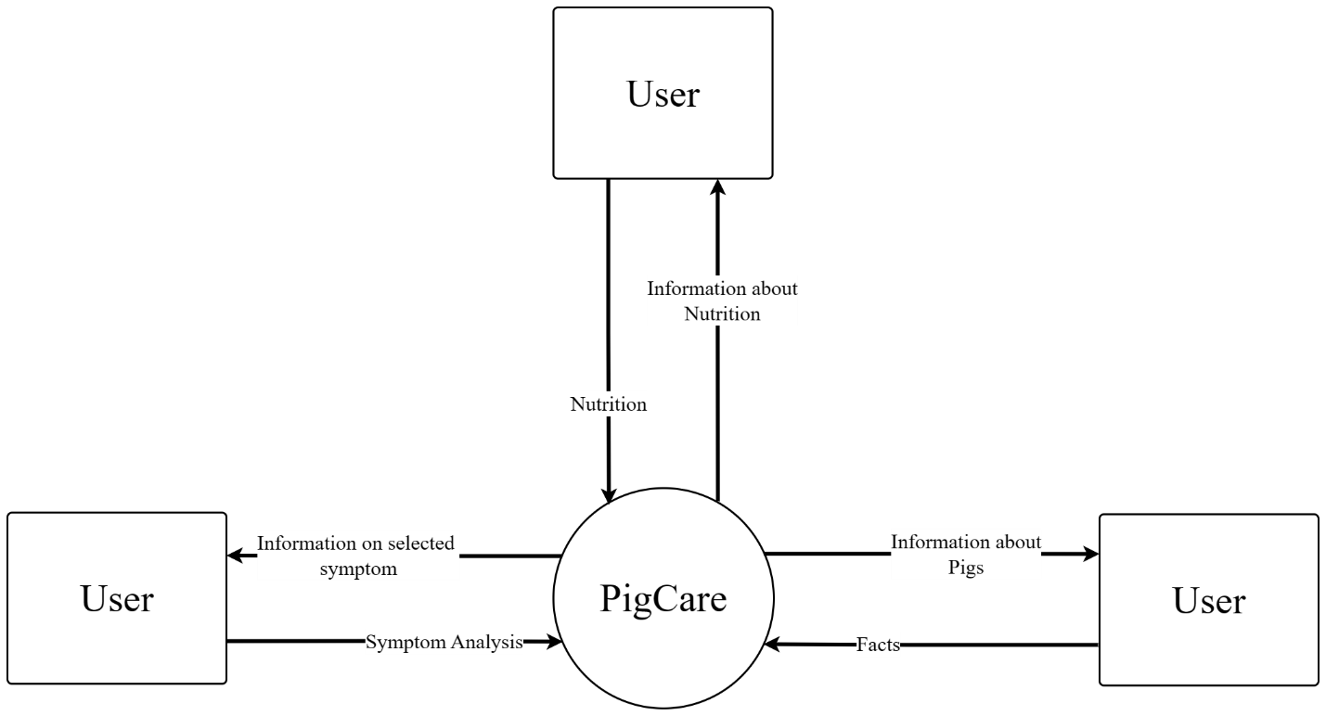

## Fig.3.3 Context Diagram

The context diagram is a high-level diagram that shows the basic user interaction using the system. In this diagram, the user gives an input and the system outputs the information. The context diagram is used to show the scope of the system and its boundaries. It is also used to show how the system interacts with external entities such as users and data sources.

# Entity Relation Diagram

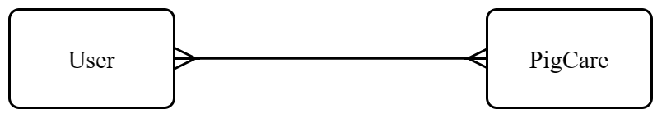An Entity Relationship Diagram (ERD) is a powerful tool that helps developers understand how data is organized and related to each other. It is a visual representation of the database structure that can help developers create and define clear relationships among the entities and attributes involved. ERDs are critical to the design and development of databases as they provide a logical structure of the database that can be easily understood by users. They serve as documentation tools and effectively communicate the logic of the database to users. ERDs are essential for any business that wants to gain a better understanding of the data contained in their database and connect the logical structure of the database to users.

## Fig 3.4 Conceptual Data Model

A high-level data model known as a conceptual data model (CDM) describes concepts and the connections between them. By identifying the business objects involved, a holistic picture of the system is presented. A CDM simulates the relationships between the business objects that should be present in a system. NOT which tables are defined, but which entities are.

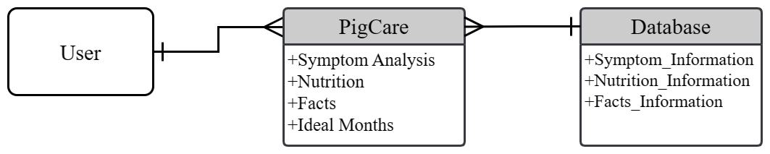

## Fig 3.5 Logical Data Model

A conceptual model is made richer by introducing operational and transactional entities and clearly describing the columns in each entity in a logical data model (LDM), which is a detailed version of a conceptual ERD. An Entity Relationship Diagram (ERD) is a visual illustration of the data that a database can store. Entity relationship diagrams (ER Diagrams), which are representations of the data structures in a table for the app 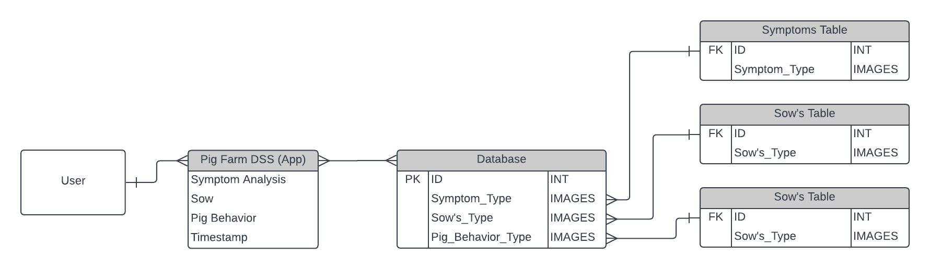database, are used to document software systems.

## Fig 3.6 Physical Data Model

The physical design of a relational database is represented by a Physical Data Model (PDM), which is a more thorough version of a Logical ERD. The logical data model is expanded upon by a physical data model, which gives each column a type, length, nullable, etc.

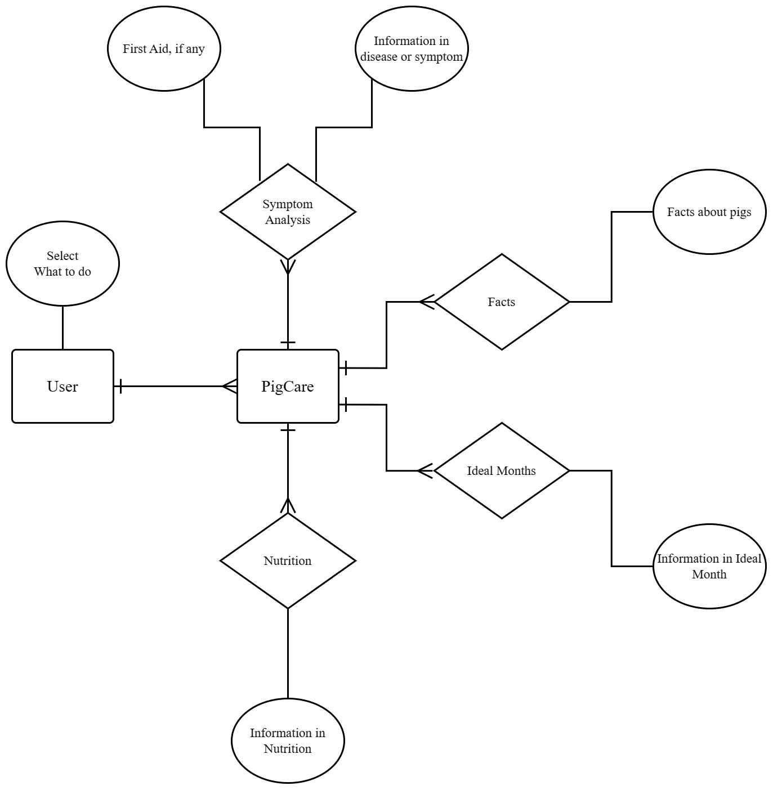

## Fig 3.7 Chen Notation Data Model

This data model shows more specific process attributes. In database and software design, Chen notation is a well-liked standard for Entity Relationship Diagrams (ERDs). Dr. Chen's proposed entity-relationship model is built on the basis of a natural understanding of how the real world is made up of entities and the relationships that exist with these defined entities.

# Data Flow Diagram

The use DFDs is to plan exactly how their new program is going to accomplish its intended purpose. DFDs help to better understand process or system operation to discover potential problems, improve efficiency, and develop better processes. They range from simple overviews to complex, granular displays of a process or system.

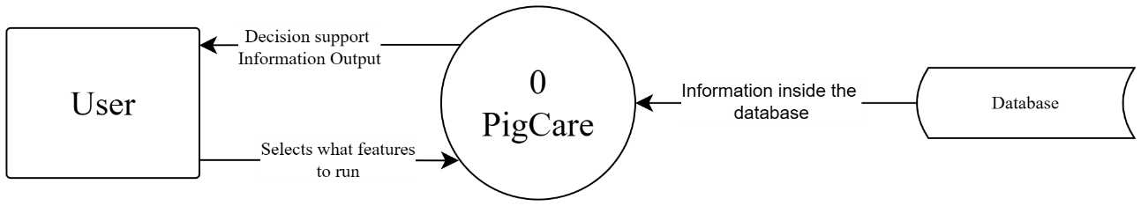

## Fig 3.8 Context Level Diagram

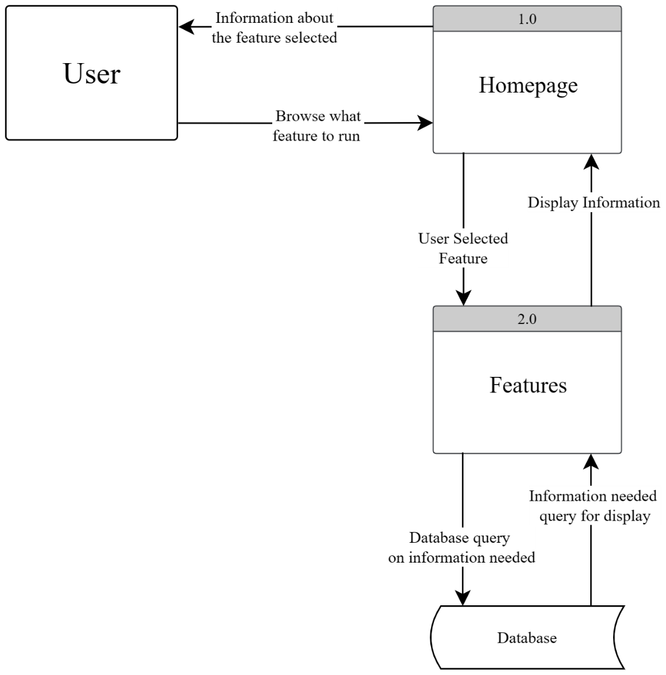

## Fig 3.9 Level 0 Level Diagram

# Fig 3.12 Sample Output